Morning,

First 10 days of the month and we are looking good for our targets, trending towards 1.5k users a day.

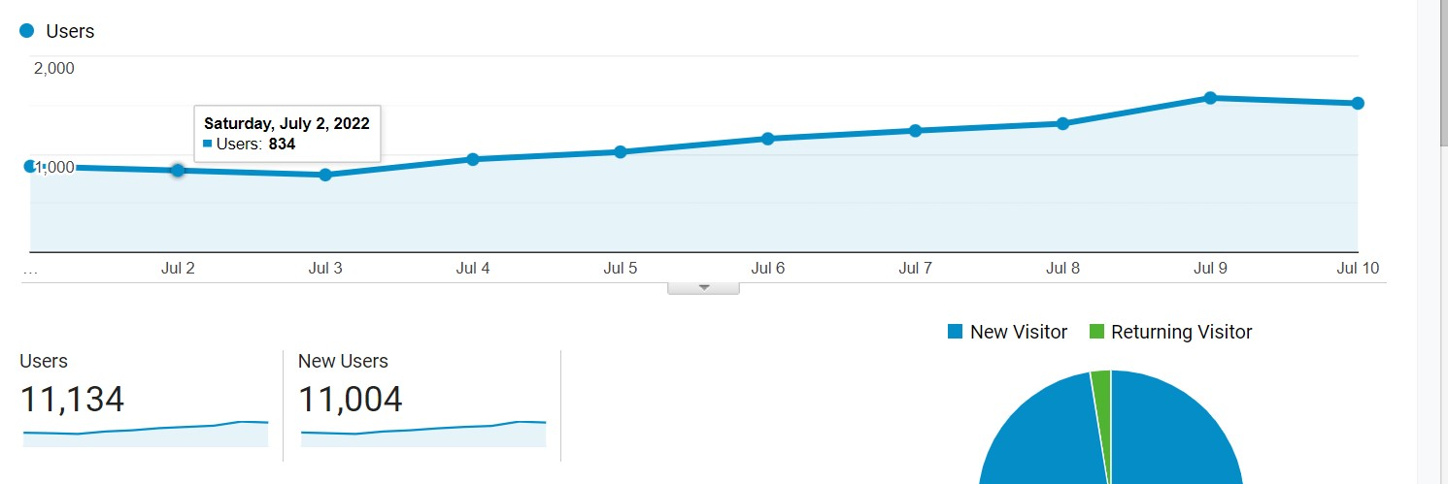

The vast majority of this is social with google search traffic accounting for, on average, 50 users a day.

The signs are good and we just need to keep squeezing out every opportunity, whether through viral social posts or utilizing reddit, to find audience.

In terms of content in the following week, we have a busy week with Wednesday and Thursday having a number of content drops for core games.

There are also the following updates/game releases:

Monday:
- Free Fire Weekly Schedule released

Tuesday:
- Wild Rift 3.2
- Apex legends Season 2

Wednesday:

- PUBG Mobile C7S7 - new season
- Genshin Impact 2.8 release

Thursday:
- Wild Rift Star Guardians event
- Legends of Runeterra Star Guardians event

Social Media Updates (04.07-10.07)
Brawl Stars, Wild Rift, and game release pieces doing very well. Apex Legends and Legends of Runeterra may be good for FB as they’re due for updates soon.

Facebook:
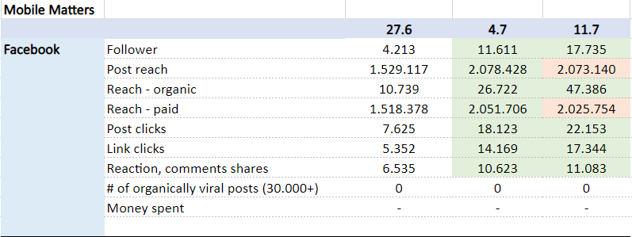
Instagram
